Exclamatory Sentences

✅ Definition:
# Source: AI Source: Provided by: [Data Path: Persons Table -> ID Column: 1, Name_En Column: Motasem Essam] -> From: [Chatgpt (GPT-4-turbo)] on [7/28/2025]
An exclamatory sentence expresses strong emotion, such as surprise, joy, anger, excitement, shock, or admiration.
It adds emotional emphasis and intensity to a statement.

🧩 Key Features of Exclamatory Sentences:
# Source: AI Source: Provided by: [Data Path: Persons Table -> ID Column: 1, Name_En Column: Motasem Essam] -> From: [Chatgpt (GPT-4-turbo)] on [7/28/2025]
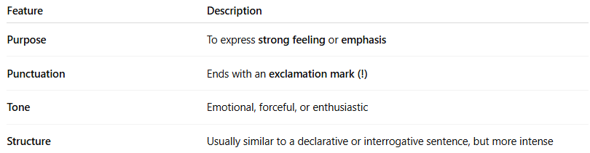
Feature | Description
Purpose | To express strong feeling or emphasis
Punctuation | Ends with an exclamation mark (!)
Tone | Emotional, forceful, or enthusiastic
Structure | Usually similar to a declarative or interrogative sentence, but more intense

✏️ Examples of Exclamatory Sentences:
# Source: AI Source: Provided by: [Data Path: Persons Table -> ID Column: 1, Name_En Column: Motasem Essam] -> From: [Chatgpt (GPT-4-turbo)] on [7/28/2025]
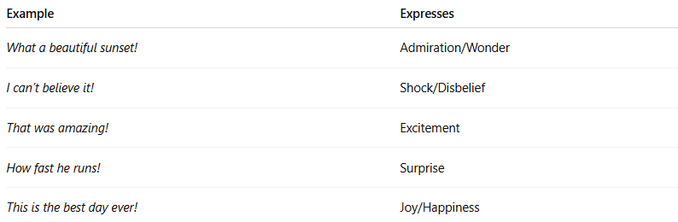
Example | Expresses
What a beautiful sunset! | Admiration/Wonder
I can’t believe it! | Shock/Disbelief
That was amazing! | Excitement
How fast he runs! | Surprise
This is the best day ever! | Joy/Happiness

🔧 Common Patterns of Exclamatory Sentences:
# Source: AI Source: Provided by: [Data Path: Persons Table -> ID Column: 1, Name_En Column: Motasem Essam] -> From: [Chatgpt (GPT-4-turbo)] on [7/28/2025]
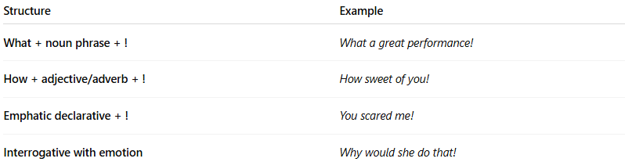
Structure | Example
What + noun phrase + ! | What a great performance!
How + adjective/adverb + ! | How sweet of you!
Emphatic declarative + ! | You scared me!
Interrogative with emotion | Why would she do that!

⚠️ Important Notes:
# Source: AI Source: Provided by: [Data Path: Persons Table -> ID Column: 1, Name_En Column: Motasem Essam] -> From: [Chatgpt (GPT-4-turbo)] on [7/28/2025]
- Exclamatory ≠ just any sentence with “!”
  - Not all sentences that end in an exclamation mark are exclamatory by function.
    - Example: Sit down! → Imperative, not exclamatory.
- Exclamatory sentences must express strong emotion, not just give orders.

🔍 Exclamatory Sentence vs. Others
# Source: AI Source: Provided by: [Data Path: Persons Table -> ID Column: 1, Name_En Column: Motasem Essam] -> From: [Chatgpt (GPT-4-turbo)] on [7/28/2025]
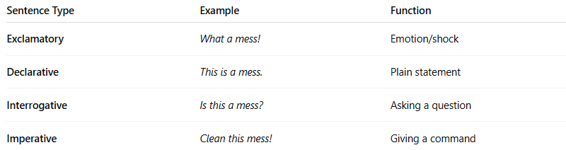
Sentence Type | Example | Function
Exclamatory | What a mess! | Emotion/shock
Declarative | This is a mess. | Plain statement
Interrogative | Is this a mess? | Asking a question
Imperative | Clean this mess! | Giving a command

🧠 Summary:
# Source: AI Source: Provided by: [Data Path: Persons Table -> ID Column: 1, Name_En Column: Motasem Essam] -> From: [Chatgpt (GPT-4-turbo)] on [7/28/2025]
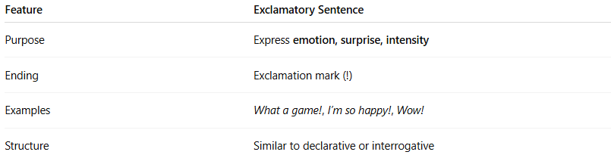

Feature | Exclamatory Sentence
Purpose | Express emotion, surprise, intensity
Ending | Exclamation mark (!)
Examples | What a game!, I’m so happy!, Wow!
Structure | Similar to declarative or interrogative

